B@tCH Parish Profile
- 2018 -
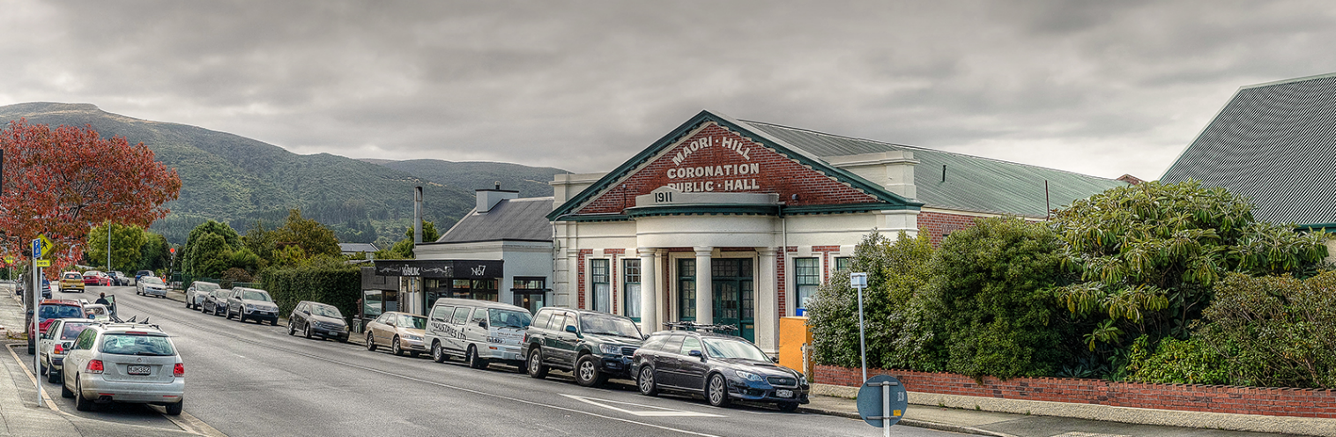
Introduction
Welcome to Breakfast at the Coronation Hall, B@tCH! Come in, grab some breakfast and join us for fellowship. This is followed by some thought-provoking teaching while we focus on Christ’s message as it’s presented to us in a way that we believe will be relevant for you, today. You are welcome here, come.

B@tCH is one of the congregations of the Highgate Presbyterian Church (Mission at Highgate or Highgate Parish) along with Highgate @10. B@tCH has its own life and independence but contributes to the funds and missions of the wider parish.

Mission
B@tCH exists to serve the people of our community and to encourage them to come into a relationship with God through Jesus Christ.

Values
Our values are shared through our:
- joy in worship
- welcoming, unpretentious worship environment
- team ministry
- active ministry of all believers
- prayer – public, personal and intercessory
- preaching rooted in God’s word
- community involvement and service

B@tCH Culture
We seek to capture the strength and excitement of the New Testament church by
- telling the story of Jesus as good news for today
- recognising the Holy spirit as the enabler of the church
- discovering, encouraging and training people in their God-given gifts
- growing a worshipping community
- providing a place of welcome and acceptance for those who have not experienced church before
- providing a healing place for those who have been hurt

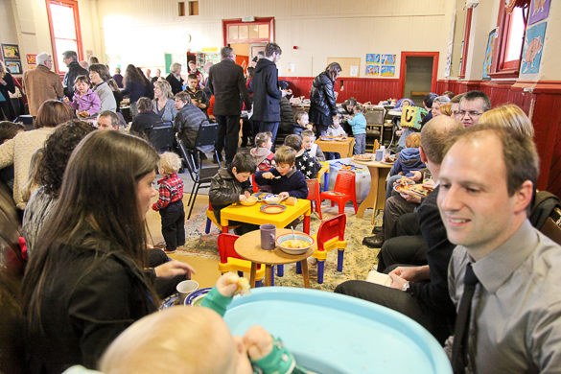
B@tCH meets on Sunday morning from 8.30am until 9.45am during school term time. The teaching is Christ centred, firmly grounded in scripture and presented to the congregation in a challenging and relevant format.

Prayer is crucial to sustaining the ministry at B@tCH for all levels and for this reason, there is a weekly prayer meeting held on a Thursday evening in a room at the Coronation Hall. It is here where a small group from within the Leadership and others meet to pray for the service and share pastoral concerns. All are welcome to attend.

B@tCH has holidays! B@tCH members are encouraged to use this time for refreshment and rest or to enjoy visiting another congregation.

B@tCH is generally in recess for two Sundays at the end of the first, second and third school terms. It has been the responsibility of the B@tCH leadership to always host the service on Good Friday morning for the whole parish and this sometimes reduces the Sundays off at the end of the first term to one. B@tCH’s last service for the year is on Christmas Eve and in the new year, the first service is on the last Sunday in January. In order to support our congregation over this holiday period, a carefully planned roster of pastoral care is organised and this is offered to the congregation throughout the breaks with names and phone numbers of leaders on call.

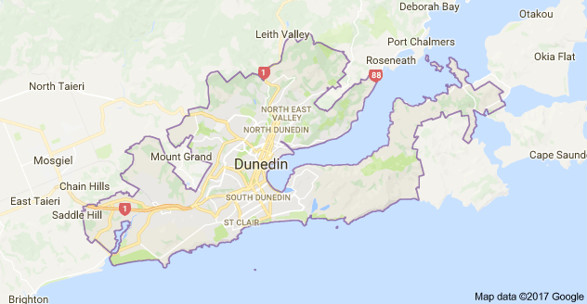
The B@tCH community, which meets in the Maori Hill Coronation Hall, is drawn from all over Dunedin and beyond, from areas including: the surrounding Hill suburbs, Anderson’s Bay, Taieri Mouth, Port Chalmers, Macandrew Bay, North East Valley, South Dunedin, Brockville, Mosgiel and Outram.
B@tCH
Currently the age range within the B@tCH community is from nought to ninety and includes a significant number of families. B@tCH children and teenagers attend primary, intermediate, high schools or colleges in nearly all of the above-mentioned suburbs. A few are home-schooled. For three or four weeks, each term a group of Columba College boarders join us for breakfast and the worship time.

All are invited to receive our weekly Thursday email. This is sent out to everyone on the B@tCH pastoral list and is considered to be the B@tCH Call to Worship for the following Sunday. It previews the coming service, including the theme and scripture references, and contains notices and information on coming church events. It is a visually attractive document as befits a modern church. A holiday edition is sent out each week during B@tCH breaks.

Pastoral care takes place in homes or cafes, and leaders’ meetings are held in homes. This practice of using community and private space rather than owning buildings to conduct church business is part of B@tCH’s culture.

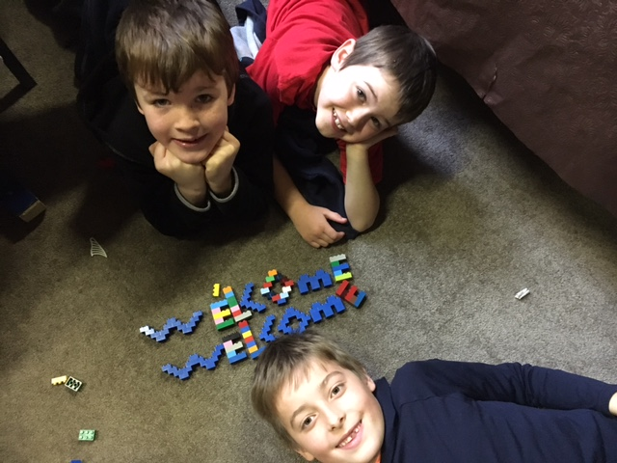
B@tCH Kids (BK’s)
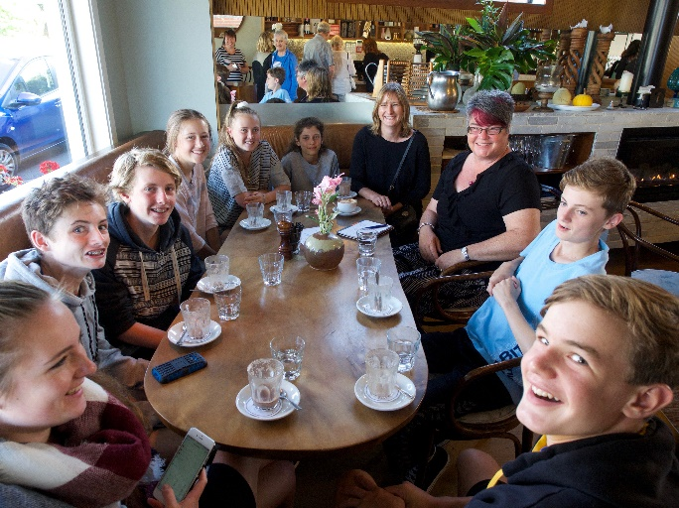
Babies and children are welcome and affirmed at B@tCH. As we frequently say in our services, “our children are our heartbeat. When we hear them, we know we are alive.” We feel it is important for our BKs (B@tCH Kids) to experience every aspect of B@tCH worship and we promote “parents as first teachers”, often asking parents to add to the BK talk of the day at home. After the children’s talk, school-aged children go out for a short lesson. Younger children begin activities in the hall while the service continues. The older children soon join them for bible-based crafts or Lego creations.

Youth Groups
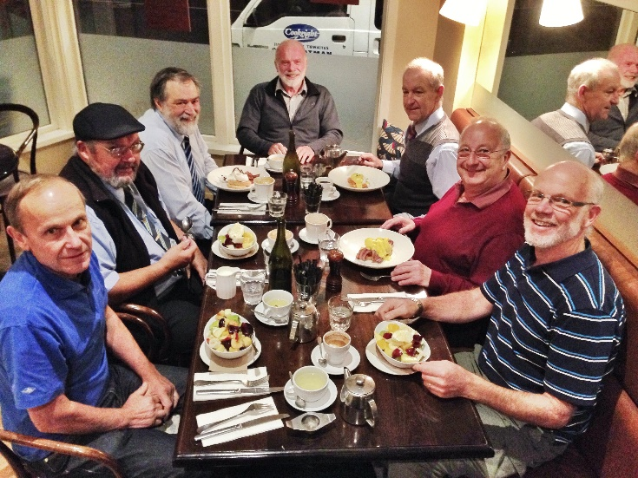
Youth group combines youth from both B@tCH and Highgate@10 from year seven to thirteen. Currently the boys and girls are meeting in separate Home Groups but the combined group meets for social events with other youth groups around town and enjoys attending the local combined Easter and Labour weekend camps.

Pre- School Group
Crafty Totz, a group for pre-schoolers is offered weekly within the parish. More information on this group can be found on our web and Facebook pages as part of the Highgate Presbyterian Church at https://highgatechurch.org.nz/

B@tCH Groups
As part of our pastoral care at B@tCH, attendees are encouraged to join one of our numerous weekly Home Groups or one of the other informal gatherings that are associated within the B@tCH community. These include: coffee after the service at an adjoining café, weekday men’s breakfasts, movie nights, and social evenings and breakfasts for ladies.

In the past a lunchtime women’s group known as “Groundswell”was meeting once or twice a term; there was “Faith Box”for families, and “A Day Away” offered two retreats for the women. Five Prayer Days gave opportunity for creative praying. Ideas continue to be brought to fruition by members of B@tCH as they see a need and the potential for such gatherings is limitless and warmly encouraged.

History, membership and finances
Following Barry Kelk’s original vision of ‘dropping the nets on the other side’, B@tCH began in 2003 when a small group from the then Maori Hill Church, all lay people, felt called to offer an informal Christian service to the community. They were drawn to the idea of sharing a meal and fellowship in the name of Jesus, and wanted to meet in a place that people associated with many different community activities rather than in a formal church building that had negative connotations for some such as mysterious rituals or other unknown activities. That place, diagonally opposite Maori Hill church, was the Coronation Hall, where school children gather for assemblies and concerts, where people vote, and other community activities are run. The group left with the blessing of the then minister of Maori Hill Church, Martin Stewart and of the Session but retains a connection with that congregation, now known as Highgate @10.

Membership of B@tCH is acknowledged in a carefully maintained “Pastoral List” of regular attenders. All are welcome to participate in Holy Communion, which is celebrated twice a term. There is a much wider readership of the weekly emailed Thursday flyer - the B@tCH Call to Worship.

From very small beginnings, B@tCH has grown. According to the B@tCH pastoral list, September, 2017, there are 106 adults regularly attending B@tCH and 51 young people of school or preschool age. There is another group who come irregularly but who still may see themselves as part of the B@tCH community. There is also a group who have left Dunedin but are still in touch with some of the B@tCH leaders. Attendance varies but the average for 2017 without the Columba girls has been 144. The pastoral list is kept updated at each leaders’ meeting and is divided into groups under a leader’s name for prayer, support and keeping in touch.

There is no formal offering taken during the B@tCH service but the offering box is located on the table just inside the door along with the food offering for Presbyterian Support. Most of the offerings are given by the envelope system and B@tCH offerings for 2016 totalled $113,611. The overall financial summary for the Highgate Parish is provided in the following paragraphs with the full set of details available in the parish annual report. B@tCH people respond generously to special causes and these have been a feature of B@tCH giving over the years. One of the annual efforts undertaken by the congregation is to provide Christmas boxes to Presbyterian Support. Approximately 70 boxes are given by B@tCH members to this agency for distribution early in December. This tradition has sparked other groups to do the same, including the workplace of one of the B@tCH leaders.

The overall finances for the Highgate parish include the two hubs of Highgate@10 and B@tCH in a single set of overall accounts. These accounts as of 30 June 2017 show total current assets of $1.4 million in predominantly fixed deposits and bank accounts. The majority of this money is earmarked for a building project at 580 Highgate to replace the existing sanctuary, scheduled for demolition because of high earthquake risk and prohibitive strengthening costs. The total non-current assets are $1.7 million. Total liabilities are only $15,000, which relate to day to day business since the church has no mortgages or loans.

The overall Highgate parish contributed $240,000 in offerings plus $44,000 in donations and sundry items last year for a total of $284,000 in annual income. Annual expenditures were $279,000 with a $5,000 surplus last year and much of the interest received from investments is used to balance the budget

B@tCH contributed $121,000 of the $240,000 total giving last year and its annual direct expenditure was $70,000 of the $279,000 total. The $70,000 covered salaries for its part time minister and pastoral assistant along with the costs of providing food, heat and Coronation Hall rental.

Leadership
Our commitment to a part-funded, part time appointment is born of experience and is integral to our character. It facilitates community connections and pastoral awareness, and it fits well with the high level of commitment and support by the wider B@tCH team. We believe that contemporary employment practices facilitate such a part-time appointment. Rev. Barry Kelk, who stepped down at the end of 2017, was the B@tCH Minister. Barry was ordained for ministry as a Locally Ordained Minister (LOM) within the Highgate Parish at B@tCH in 2006 and after that, he received a half time stipend. Now B@tCH is entering a new phase and we anticipate working with the new minister to find the best form of leadership going forward.
From 2010 until September 2016, a pastoral assistant with responsibility particularly among the women was employed for eight hours per week. This task is currently carried by a small group, but a new pastoral assistant is being sought for 2018. At present Joanne Hawker, is a volunteer Pastoral Assistant for Families and supports the families with young children. This is an unpaid role to which Jo has committed to 3 hours per week. She also ensures smooth running of the BK’s (B@tCH Kids) activity each Sunday.

Currently there are twelve members on the B@tCH Leadership Team, which meet twice a term. Three of the team and the minister represent B@tCH on the Highgate Parish Council.

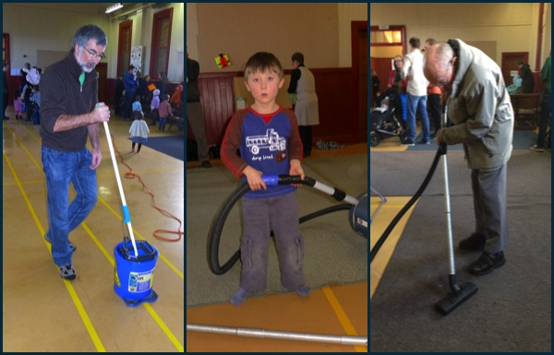
Resources
B@tCH runs smoothly because of the time and energy put in by many, week in week out. Hall set up and tidy up, kitchen preparation of breakfast, laying the table, dishes, food pick up, BK’s activity, care of food basket, sound and vision technicians, musicians, singers, leading prayers for others, bible readings, sharing of a special verse – there is something for everyone and we encourage, people to be involved. However, there are no life sentences at B@tCH and each year, the leaders personally thank each person who has taken up a key task and gives them permission to step down. Many choose to commit again but the invitation to rest is given to all.

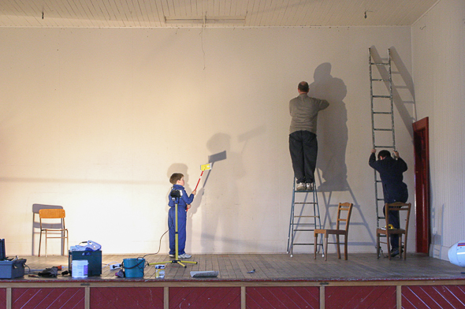
As B@tCH meets in the Coronation Hall and does not own a building, it has very few overheads. The annual rent paid to Maori Hill School for use of the hall and a storage room is approximately $1600. The heating is run on a meter system and costs are $560 on average for the year. B@tCH does not have its own office space but facilities such as photocopying are available through the Highgate Church office, currently operating out of a portacom in front of the church halls.

There is now no manse attached to the Highgate Parish. Ministers instead receive a housing allowance.

Governance
Highgate@10 has a full time minister in Rev. Geoffrey Skilton. Once a new minister is called to B@tCH, we expect the two ministers will work closely together as happened before the vacancy.

The Highgate Presbyterian Church Parish Council oversees the worship and work of the two congregations. It has three members each from B@tCH and Highgate@10. Due to the earthquake risk in the church sanctuary and office structures at 580 Highgate, the Highgate @10 congregation is currently worshipping in the Coronation Hall immediately after the B@tCH service. Once the demolition is complete and the modern adjoining halls are made safe, Highgate@10 will be returning to worship in the halls of the church building. B@tCH will continue to worship in the Coronation Hall. If the Coronation Hall were to be unavailable for any reason, it would be our intention to hire a similar alternative community venue, in keeping with our initial vision.

The congregation’s voice – Strengths and Goals
In preparation for this parish profile, the B@tCH congregation was surveyed to find out what they most valued about B@tCH and what their hopes were for the future.
They identified the strongest features of B@tCH as:
- the fellowship,
- the breakfast and
- the thought-provoking preaching, together with
- the focus on Christ’s message presented in a relevant way.

These were closely followed by the music, the involvement of all ages, the time of the service and the balance between formal and informal. More than one person also liked the fact that children are involved and that we accept a ‘noisy’ church with lots of encouragement from the front. Finally, people valued the pastoral care, the fact that there are lots of boys and men attending, and the length of the service with its honest message.

Going forward people would like continuity with many of the same strengths to be valued. However, they would also like more fellowship opportunities off site, especially for families, the reinstatement of the pastoral assistant position, some newer music and more input from younger parents. There is also a desire to have leaders who listen and who take time to get to know individuals and who encourage us all to mix more. While the current format was valued, we are encouraged to try new initiatives. One of these would be to pare down the breakfast at regular intervals and give the money saved to a Christian charity.

Opportunities for Outreach
Although many of the B@tCH congregation come from all over the city, there remain opportunities for outreach within the immediate community. However, B@tCH would like to reach new people and to fulfil one of its goals as a seeker church, especially welcoming the unchurched or those who have found previous church experiences daunting or inhospitable. There may also be opportunities for a number of other initiatives that are not being covered by the other congregations. Some of these have been hinted at by the congregation in their responses to the survey.

The surrounding community
B@tCH meets in the heart of Maori Hill, but as previously shown, it draws its community members from all over Dunedin. Gone are the days, it would seem, of parishes being the streets immediately surrounding the church building. Dunedin is a small city and travel from its outer reaches on a Sunday morning at 8.30am takes very little time.
Maori Hill is one of the older and most established suburbs in the city. The median house price for Dunedin in May, 2018 was $370,870. In Maori Hill it was $629,682.

There are several schools in the area: Maori Hill and Kaikorai are both primary schools, years 1-6. Balmacewen Intermediate for years 7-8 is just down the road. There are two integrated Presbyterian schools, John McGlashan College for boys, years 7-13 and Columba College Area School, years 1-6 co-educational, and years 7-13, girls only. Both have boarding schools. Between Maori Hill and the city is St. Hilda’s Collegiate for girls, years 7-13, which is also integrated and has a boarding house. A little further away are the closest state single-sex secondary schools, Otago Boys and Otago Girls High Schools. Logan Park High School and Kaikorai Valley College, both co-educational, are a short drive away.

There is a Montessori preschool in Maori Hill. The closest kindergarten is in the adjoining suburb of Wakari, and there is a play centre and kindergarten in Roslyn, a neighboring suburb. Other facilities include two cafes, a dairy, a hairdresser, and a garage for automobile repairs. Maori Hill is a short walk, about 20 minutes, from the city centre and being a northern suburb, it is close to Otago University. The city’s swimming pool, Moana Pool, is just down the hill in the attractive Town Belt, a green area which runs along the base of the hill suburbs.

The future
B@tCH has in its 15 years grown from a vision. It began on a non-church site with 20 committed people. It has grown to a congregation of 144. However, there is room for more growth, not just numerically but in mission to the community and beyond. Although B@tCH has developed a strong culture, it is open to a new vision and pathways so that the love of Jesus can be known more widely. The leadership and people of B@tCH hope to discover these new pathways as they work with a new leader or team.

