B@tCH Parish Profile: 2018-19

Introduction
Welcome to Breakfast at the Coronation Hall, B@tCH! Come in, grab some breakfast and join us for fellowship. This is followed by some thought-provoking teaching while we focus on Christ’s message as it’s presented to us in a way that we believe will be relevant for you, today. You are welcome here. Come.

B@tCH meets on Sunday morning from 8.30am until 9.45am during school term time. The teaching is Christ-centred, firmly grounded in scripture and presented to the congregation in a challenging and relevant format.

B@tCH is one of the congregations of the Highgate Presbyterian Church (Mission at Highgate or Highgate Parish) along with Highgate @10. B@tCH has its own life and independence but contributes to the funds and missions of the wider parish.

Our Mission
B@tCH exists to serve the people of our communities and to encourage them to come into a relationship with God through Jesus Christ.

Our Values
Our values are shared through our
- joy in worship
- welcoming, unpretentious worship environment
- team ministry and active ministry of all believers
- prayer – public, personal and intercessory
- preaching rooted in God’s word
- community involvement and service
B@tCH Culture
We seek to capture the strength and excitement of the New Testament church by
- telling the story of Jesus as good news for today
- recognising the Holy spirit as the enabler of the church
- discovering, encouraging, and training people in their God-given gifts
- growing a worshipping community
- providing a place of welcome and acceptance for those who have not experienced church before
- providing a healing place for those who have been hurt

Prayer is crucial to sustaining the ministry at B@tCH for all levels and for this reason, there is a weekly prayer meeting held on a Thursday evening in a room at the Coronation Hall. All are welcome to attend.

B@tCH has holidays! B@tCH members are encouraged to use this time for refreshment and rest or to enjoy visiting another congregation.

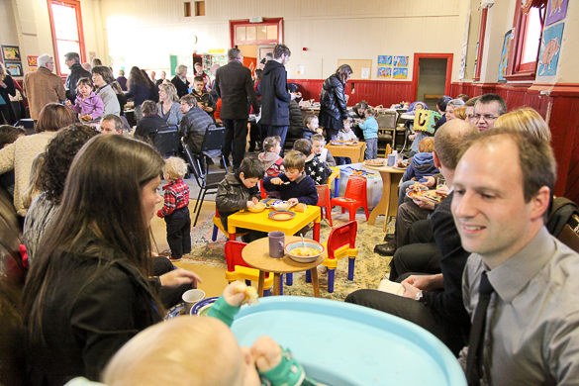
B@tCH is generally in recess for two Sundays at the end of the first, second and third school terms. It has been the responsibility of the B@tCH leadership to always host the service on Good Friday morning for the whole parish and this sometimes reduces the Sundays off at the end of the first term to one. B@tCH’s last service for the year is on Christmas Eve and in the new year, the first service is on the last Sunday in January. In order to support our congregation over this holiday period, a carefully planned roster of pastoral care is organised and this is offered to the congregation throughout the break with names and phone numbers of leaders on call.

The B@tCH community, which meets in the Maori Hill Coronation Hall, is drawn from all over Dunedin and beyond, from areas including: the surrounding Hill suburbs, Anderson’s Bay, Taieri Mouth, Port Chalmers, Macandrew Bay, North East Valley, South Dunedin, Brockville, Mosgiel and Outram.

Currently the age range within the B@tCH community is from nought to ninety and includes a significant number of families. B@tCH children and teenagers attend primary, intermediate, high schools or colleges in nearly all of the above-mentioned suburbs. A few are home-schooled. For three or four weeks each term a group of Columba College boarders join us for breakfast and the worship time.

All are invited to receive our weekly Thursday email. This is sent out to everyone on the B@tCH pastoral list and is considered to be the B@tCH Call to Worship for the following Sunday. It previews the coming service, including the theme and scripture references, and contains notices and information on coming church events. It is a visually attractive document as befits a modern church. A holiday edition is sent out each week during B@tCH breaks.

Pastoral care takes place in homes or cafes, and leaders’ meetings are held in homes. This practice of using community and private space rather than owning buildings to conduct church business is part of B@tCH’s culture.
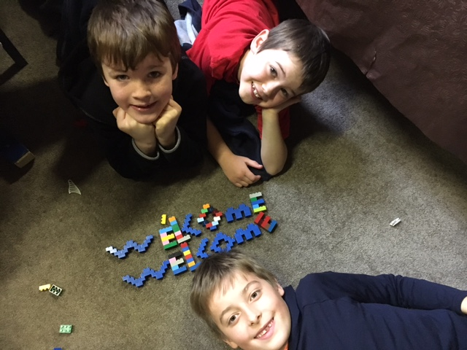
B@tCH Kids (BK’s)
Babies and children are welcome and affirmed at B@tCH. As we frequently say in our services, “our children are our heartbeat. When we hear them, we know we are alive.” We feel it is important for our BK’s to experience every aspect of B@tCH worship and we promote “parents as first teachers” often asking parents to add to the BK’s talk of the day at home.

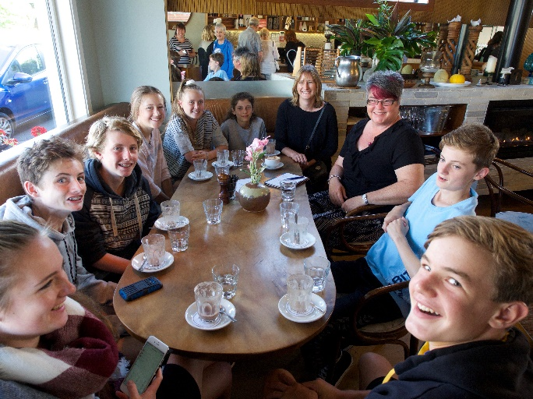
Youth group combines youth from both B@tCH and Highgate@10 from years seven to thirteen. Currently the boys and girls are meeting in separate Home Groups but the combined groups meet for social events with other youth groups around town and enjoy attending the local combined Easter and Labour weekend camps.

Crafty Totz, a group for pre-schoolers is offered weekly within the parish. More information on this group can be found on our web and Facebook pages as part of the Highgate Presbyterian Church at https://highgatechurch.org.nz/

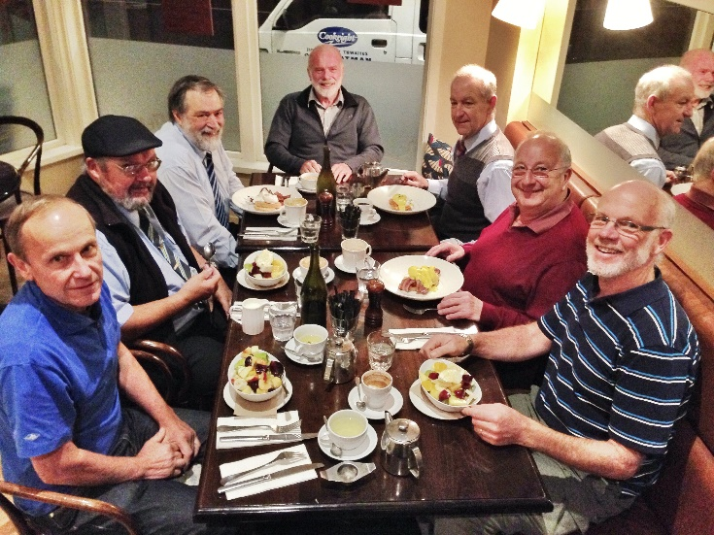
Community B@tCH Groups
As part of our pastoral care at B@tCH, attendees are encouraged to join one of our numerous weekly Home Groups or one of the other informal gatherings that are associated within the B@tCH community. These include: coffee after the service at an adjoining café, weekday men’s and woman’s breakfasts, movie nights, and social evenings.

In the past a lunchtime women’s group known as “Groundswell” was meeting once or twice a term; there was “Faith Box” for families, and “A Day Away” offered two retreats for the women. Five Prayer Days gave opportunity for creative praying. Ideas continue to be brought to fruition by members of B@tCH as they see a need and the potential for such gatherings is limitless and warmly encouraged.

History, membership and finances
Following Barry Kelk’s original vision of ‘dropping the nets on the other side’, B@tCH began in 2003 when a small group from the then Maori Hill Church, all lay people, felt called to offer an informal Christian service to the community. They were drawn to the idea of sharing a meal and fellowship in the name of Jesus, and wanted to meet in a place that people associated with many different community activities rather than in a formal church building that had negative connotations for some such as mysterious rituals or other unknown activities. That place, diagonally opposite Maori Hill church, was the Coronation Hall, where school children gather for assemblies and concerts, where people vote, and other community activities are run. The group left with the blessing of the then minister of Maori Hill Church, Martin Stewart and of the Session, but retains a connection with that congregation, now known as Highgate @10.

Membership of B@tCH is acknowledged in a carefully maintained “Pastoral List” of regular attenders. All are welcome to participate in Holy Communion, which is celebrated twice a term. There is a much wider readership of the weekly emailed Thursday flyer - the B@tCH Call to Worship.

From very small beginnings, B@tCH has grown. According to the current B@tCH pastoral list, there are 88 adults regularly attending B@tCH and 43 young people of school or preschool age. There is another group who come irregularly but who still may see themselves as part of the B@tCH community. There is also a group who have left Dunedin but are still in touch with some of the B@tCH leaders. Attendance varies but the average for 2018 without the Columba girls has been 126. The pastoral list is kept updated at each leaders’ meeting and is divided into groups under a leader’s name for prayer, support and keeping in touch.

There is no formal offering taken during the B@tCH service. However, an offering box is located on the table just inside the door along with the food offering for Presbyterian Support. Most of the offerings are given by the envelope system and B@tCH offerings for 2017-8 totalled $119,745. The overall financial summary for the Highgate Parish is provided in the following paragraphs with the full set of details available in the parish annual report. B@tCH people respond generously to special causes and these have been a feature of B@tCH giving over the years. One of the annual efforts undertaken by the congregation is to provide Christmas boxes to Presbyterian Support. Approximately 70 boxes are given by B@tCH members to this agency for distribution early in December. This tradition has sparked other groups to do the same, including the workplace of one of the B@tCH leaders.

The overall finances for the Highgate parish include the two hubs of Highgate@10 and B@tCH in a single set of overall accounts. These accounts as of 30 June 2018 show total current assets of $1.4 million in predominantly fixed deposits and bank accounts. The majority of this money is earmarked for a building project at 580 Highgate to replace the existing sanctuary, scheduled for demolition because of high earthquake risk and prohibitive strengthening costs. The total non-current assets are $1.7 million. Total liabilities are only $15,000, which relate to day to day business since the church has no mortgages or loans.

The overall Highgate parish contributed $244,484 in offerings plus $14,300 in donations and sundry items last year for a total of $258,784 in annual income. Annual expenditures were $287,373 and much of the interest received from investments is used to balance the budget.

B@tCH contributed $119,745 of the $244,484 total giving last year and its annual direct expenditure was $49,000 of the $287,373 total. The $49,000 covered part of the salary for the departing part time minister along with the costs of providing food, heat and Coronation Hall rental.

Leadership
B@tCh is seeking a minister for up to 0.75 of a full stipend. This fits with our commitment to using the considerable gifts within B@tCH to share the leading and speaking and provide some of the pastoral care. It also allows the new leader more flexibility to work in areas of their strongest calling within the B@tCH ministry, and enables the establishment of community relationships through paid work, study or voluntary activities, which fits with our outward looking focus.
From 2010 until September 2016, a pastoral assistant with responsibility particularly among the women was employed for eight hours per week. This task is currently carried by a pastoral team of 3 women and 3 men.
Currently there are fourteen members on the B@tCH Leadership Team, which meets twice a term. Three of the team represent B@tCH on the Highgate Parish Council.

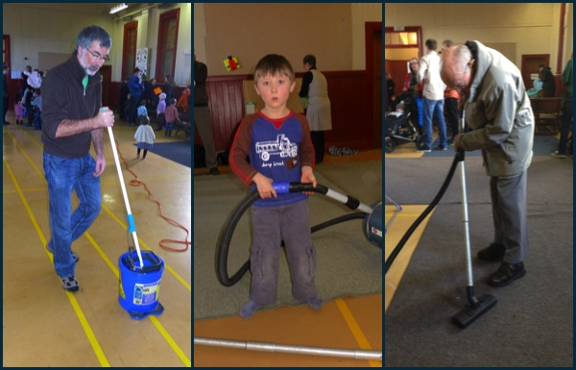
Resources
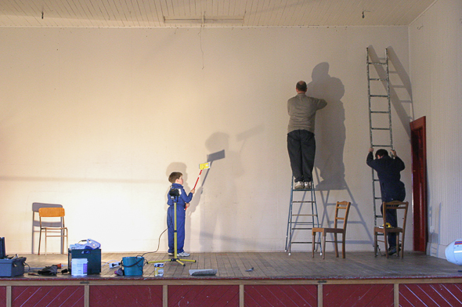
B@tCH runs smoothly because of the time and energy put in by many, week in week out. Hall set up and tidy up, kitchen preparation of breakfast, laying the table, dishes, food pick up, BKs activity, care of food basket, sound and vision technicians, musicians, singers, leading prayers for others, bible readings, sharing of a special verse – there is something for everyone and we encourage, people to be involved. However, there are no life sentences at B@tCH and each year, the leaders personally thank each person who has taken up a key task and gives them permission to step down. Many choose to commit again but the invitation to rest is given to all.

As B@tCH meets in the Coronation Hall and does not own a building, it has very few overheads. The annual rent paid to Maori Hill School for use of the hall and a storage room is approximately $1600. The heating is run on a meter system and costs are $774 on average for the year. B@tCH does not have its own office space but facilities such as photocopying are available through the Highgate Church office, currently operating out of a portacom in front of the church halls.

There is now no manse attached to the Highgate Parish. Ministers instead receive a housing allowance.

Governance
Highgate@10 has a full time minister in Rev. Geoffrey Skilton. Once a new minister is called to B@tCH, we expect the two ministers will work closely together as happened before the vacancy.

The Highgate Presbyterian Church Parish Council oversees the worship and work of the two congregations. It has three members each from B@tCH and Highgate@10. Due to the earthquake risk in the church sanctuary and office structures at 580 Highgate, the Highgate @10 congregation is currently worshipping in the Coronation Hall immediately after the B@tCH service. Once the demolition is complete and the modern adjoining halls are made safe, Highgate@10 will be returning to worship in the halls of the church building. B@tCH will continue to worship in the Coronation Hall. If the Coronation Hall were to be unavailable for any reason, it would be our intention to hire a similar alternative community venue, in keeping with our initial vision.

Opportunities for Outreach
Although many of the B@tCH congregation come from all over the city, there remain opportunities for outreach within the immediate community. However, B@tCH would like to reach new people and to fulfil one of its goals as a seeker church, especially welcoming the unchurched or those who have found previous church experiences daunting or inhospitable. There may also be opportunities for a number of other initiatives that are not being covered by the other congregations.

The Surrounding Community
B@tCH meets in the heart of Maori Hill, but as previously shown, it draws its community members from all over Dunedin. Gone are the days, it would seem, of parishes being the streets immediately surrounding the church building. Dunedin is a small city and travel from its outer reaches on a Sunday morning at 8.30am takes very little time.

There are several schools in the area: Maori Hill and Kaikorai are both primary schools, years 1-6. Balmacewen Intermediate for years 7-8 is just down the road. There are two integrated Presbyterian schools, John McGlashan College for boys, years 7-13 and Columba College Integrated Composite School, years 1-6 co-educational, and years 7-13, girls only. Both have boarding houses. Between Maori Hill and the city is St. Hilda’s Collegiate for girls, years 7-13, which is also integrated and has a boarding house. A little further away are the closest state single-sex secondary schools, Otago Boys and Otago Girls High Schools. Logan Park High School and Kaikorai Valley College, both co-educational, are a short drive away.

There is a Montessori preschool in Maori Hill. The closest kindergarten is in the adjoining suburb of Wakari, and there is a play centre and kindergarten in Roslyn, a neighbouring suburb. Other facilities include two cafes, a dairy, a hairdresser, and a garage for automobile repairs. Maori Hill is a short walk, about 20 minutes, from the city centre and being a northern suburb, it is close to Otago University. The city’s swimming pool, Moana Pool, is just down the hill in the attractive Town Belt, a green area which runs along the base of the hill suburbs.

The Future
B@tCH has in its 15 years grown from a vision. It began on a non-church site with 20 committed people. It has grown to a congregation of 126. However, there is room for more growth, not just numerically but in mission to the community and beyond. Although B@tCH has developed a strong culture, it is open to a new vision and pathways so that the love of Jesus can be known more widely. The leadership and people of B@tCH hope to discover these new pathways as they work with a new leader or team.

